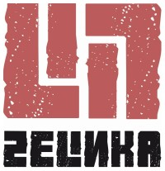
Press Release Zelinka

Zelinka is the name for a strong rockjazzfunkbluesy instrumental project, founded in September 2010 by guitar player Bernd Fleischer, whose grandfather Johannes Zelinka gave his name. The trio is being completed by Torsten Grossmann (bass guitar) and Kay Rohr (drums) – three grown musicians with a total of over 90 years on stage. Versatility and an untamed joy of playing are Zelinkas obvious marks.

Zelinkas versatile sound combines rocking, blues-influenced, funky and even jazzy tones. Playing elemental guitar rock the musicians mostly feature their own compositions leaving enough freedom to improvise.

Their first album “Zelinka” – released in 2013 – contains 10 tracks by Bernd Fleischer and Torsten Grossmann. All told it’s instrumental rock music that features Bernd Fleischer’s strong guitar play.

Contact:

Zelinka
Torsten Grossmann
Buchenallee 57
04435 Schkeuditz / Germany
Tel: +49 (0)34204 / 63703
Fax: +49 (0)34204 / 63703
Mail: info@zelinka-music.com
Web: www.zelinka-music.com

More information and photos: http://www.zelinka-music.com/press/

